

**Muhammad Fahad**

**(FA19-BSSE-0014)**

**Business Process Engineering**

**Nauman Hafeez Ansari Assignment no 3**

**Process Discovery**

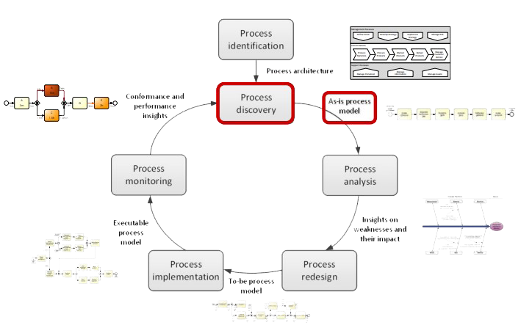

Process Discovery Methods

|  |  |  |  |  |  |  |  |  |
| --- | --- | --- | --- | --- | --- | --- | --- | --- |
| |  | | --- | | **Evidence Based** | | |  | | --- | | **Interview based** | | | | |  | | --- | | **Automated Process** | | |
| Document analysis | | Observation | Automated process | |

**Qualitative & Quantitative**

**Analysis**

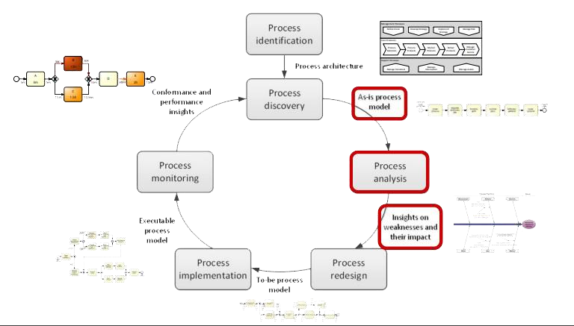

Processes of Qualitative & Quantitative Analysis

|  |  |  |
| --- | --- | --- |
| **Qualitative Analysi**  **s**    Value  -  Added &  Waste  Analysis    Root  -  Cause  Analysis    Pareto    Analysis    Issue    Register | **Quantitative**  **Analysis**    Flow    Analysis | |
| |  | | --- | | Queuing Analysis | | |  | | --- | | Simulation | |